CREATION OF ACL-WRITE
- Click New to create a new ACL(Write)
- Enter the following details:
- Type: record
- Operation: Write
- Name: u_institution_details
- Active: true
- In the Requires role related list, add:
- bb3 (custom role)
- No need to add any Data condition
- Save the ACL Record
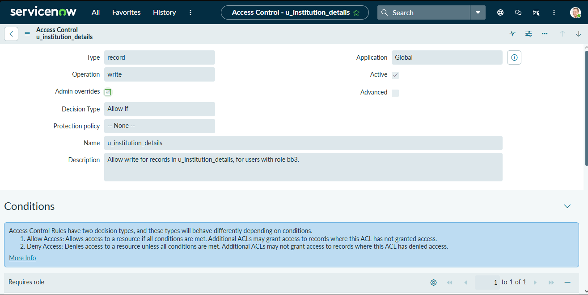
Screenshot – ACL Write Configuration

